**Real Estate & Private Equity Introduction**

**1)Overview** (what will be covered in the presentation)

* Real Estate and Private Equity applications used at HOOPP
* Introduction to each of these applications
* IT’s role in supporting these applications

**2)What is MRI?**

* Accounting system for Real Estate
* Balance sheets, income statements, and trial balances
* Tracks properties and leases
* Ability to import external data into the system
* Purchased by Intuit
* Users: Real Estate (back office); Real Estate (front office)

**3)Architecture**

* 3 environments: DEV, UAT, PRODUCTION



4)**Databases**

Production Box – contains two databases:

1. MRI_UAT
2. MRI_PROD

We can switch databases while logged in.

*Can only have one version of MRI installed per workstation. (That is we cannot have a production box and a UAT box installed on the same workstation)*

**5) MRI User Interface**

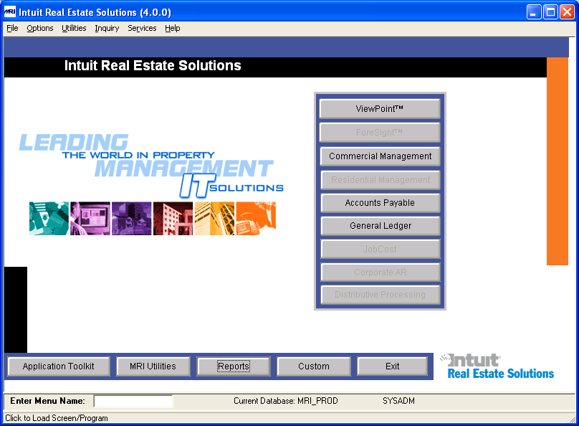

**Menu Options**

* Switching between databases
* Navigator View
* Change User Preferences
* Security Console

**6) Application Toolkit**

i)Database Design

* New feature in version 4.0.
* Enables users to view the table structure without having to go through SQL.
* Any customization to the tables must be made here (and not in SQL)

Sample Table (ACCOUNT):

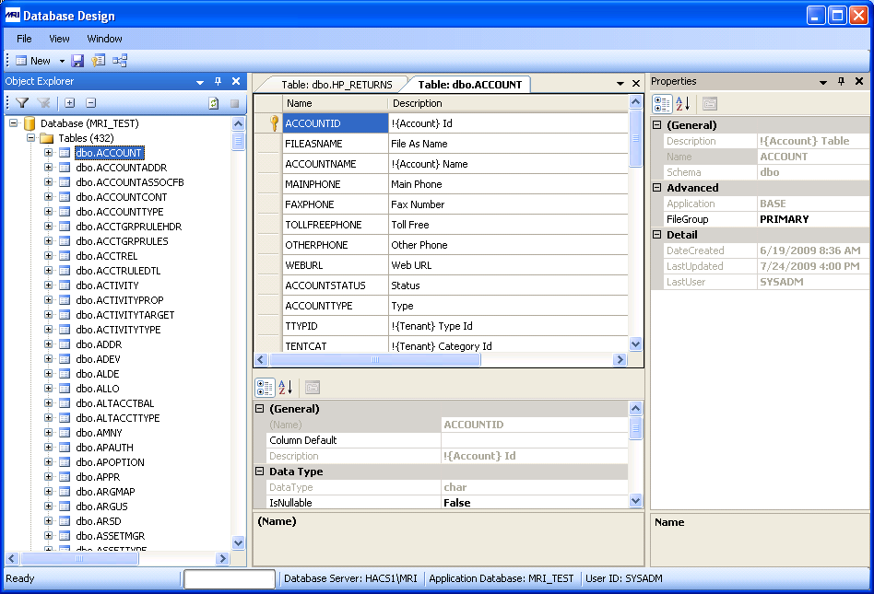

ii)Report Design

* Combination of SQL syntax and MRI’s proprietary language; similar to Visual Basic in many respects
* Usually we are making modifications of existing reports, based on user requirements

(e.g. An additional column)

* Naming convention of reports.
* Sample report: **HF_LEADGA (Lead Sheet – Non-Recoverable General & Administrative)**
* Report Expressions
* Can define ranges, account numbers, etc in some of the fields
* Not all fields will be visible on the report – right click on the field to learn more detail

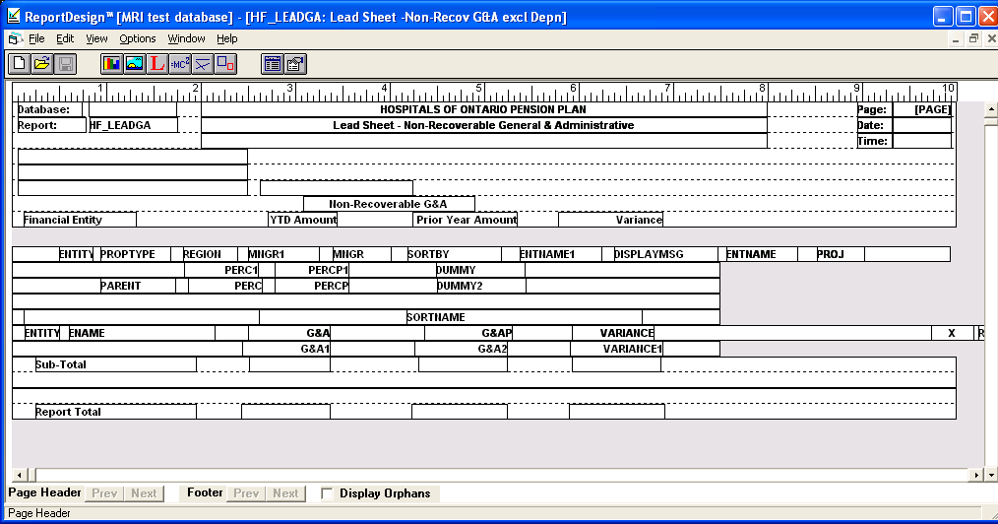

7)**Reports**

*Reports -> Run Report*

Various Options available when running reports:

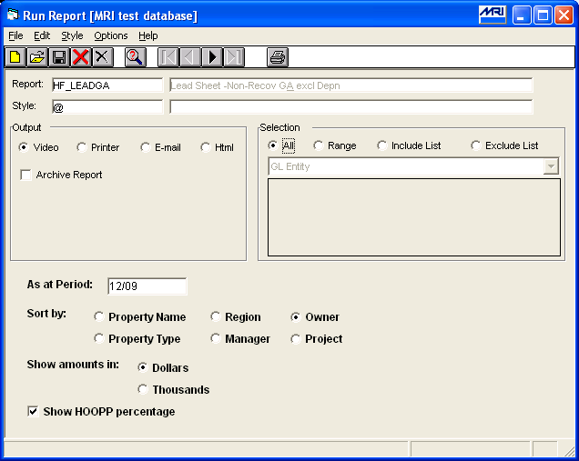

*After the report is finished, we can export the results either to Excel or Word.*

**8)SQL Queries**

* Report writer can be complex to use
* Can directly query, update, modify, and delete records in MRI
* Excellent tool for users to extract data quickly to check data integrity.
* Pre-defined queries available

*Example: HM_GHIS*

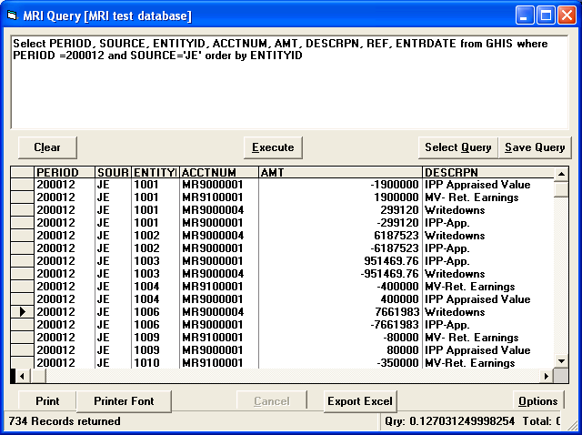

**9) General Ledger**

* More on the business side
* However, there are some important features that are useful to know

i) GL Data Entry

* for journal entries, prior period adjustments, and prior year adjustments

ii)Setup and Maintenance

*General Ledger -> Setup and Maintenance -> Chart of Accounts*

* 1000: assets; 2000: liabilities; 3000: equity
* 4000: revenue; 5000 – 7000: expenses/fees
* 8000: gains/losses; 9000 - special

Would not expect the chart of accounts to change very often

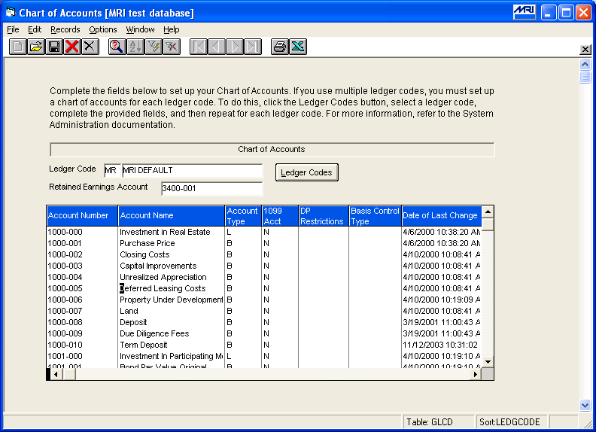

*General Ledger -> Setup and Maintenance -> Financial Formats*

Acts as a template for reports; you can choose which accounts to display.

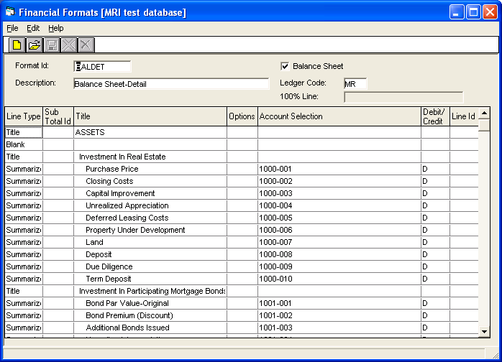

A report using this Financial Format is **HF_BALST**:

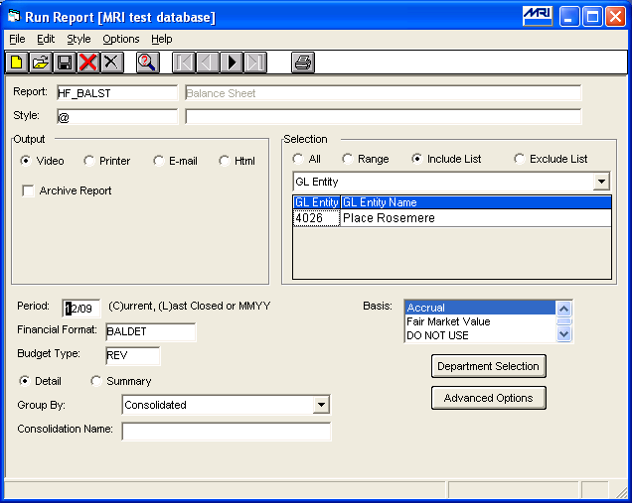

**9)Month-end Procedures**

* Real-Estate Development Portal
* Enables property managers to upload their monthly files

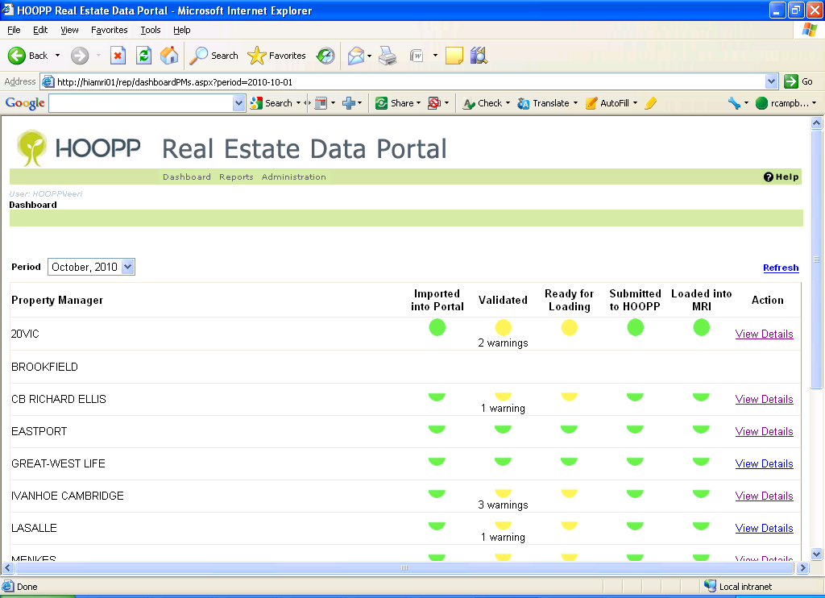

* The real estate accounting group can determine whether they would like to accept/reject these files.

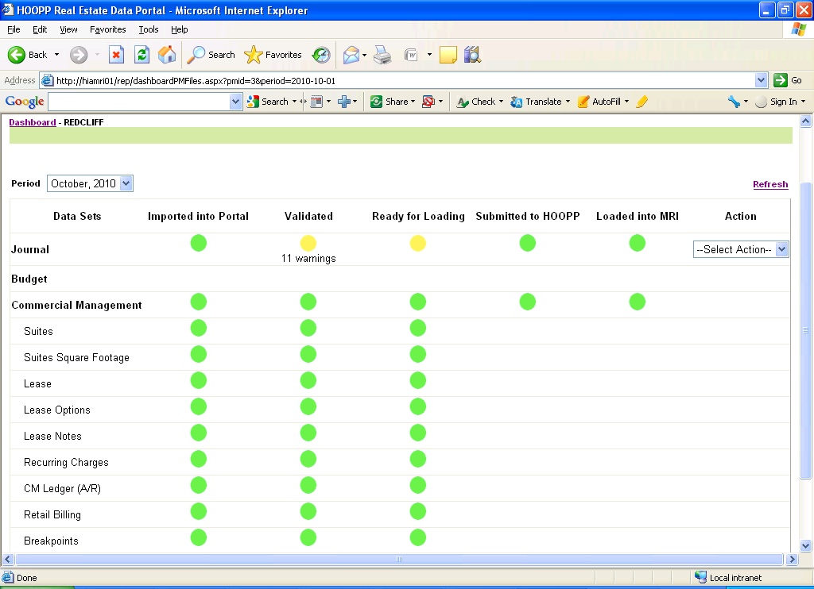

* *Depending on the type of property manager, some of the files may not be applicable:*

e.g. Eastport does not submit files for Retail Billing

**10) Private Equity**

* Application called private-I supported by the Burgiss Group.
* Used by the Private Equity group (Front Office/Back Office)
* Mainly running reports
* We are currently using version 4.5.4.7
* IT’s support is limited to technical issues (e.g. unable to launch the application, setup in test environment, etc.)

**11) Reports**

* Unlike MRI, we do not create reports for users – they run generic reports created by the vendor.

*Sample report - Adjusted Ending Value Local Amounts:*

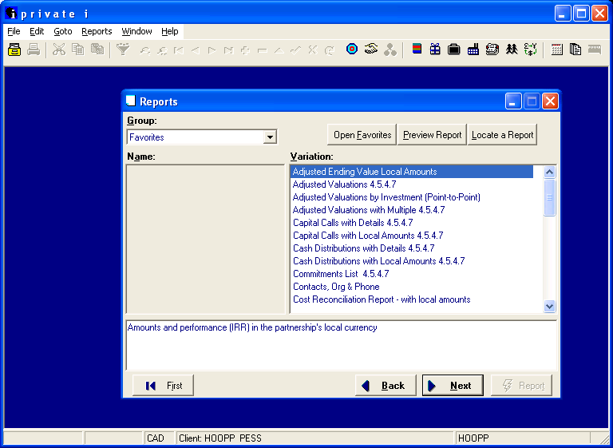

* For private equity, certain columns are generic to Private Equity (such as Paid-in Capital, Cumulative Distributions, IRR)
* Save report in .pdf format

**12) Graphs & Charts**

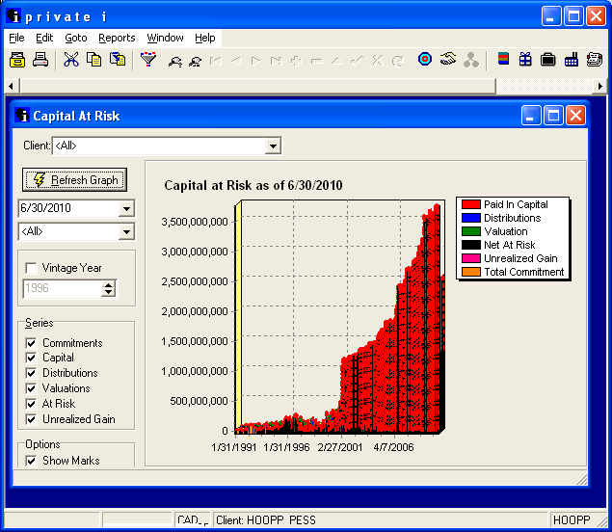

**13) Available Documentation**

**i) MRI**

*Procedures*

R:\intranet_docs\investment\MRI

*Recent Implementations*

R:\smart

Real Estate Development Portal (REDP)

X:\IFI\Real Estate Project (REP)\Work Packages\03 - Vision Replacement

**ii)Private-i**

*The following directory contains how-to guides, report tutorials, etc.*

R:\intranet_docs\investment\PrivateiDocs\